HTML5

Theory Assignment

• Question 1: Difference b/w HTML & HTML5?

Ans:

Html:it is earlier version of html.

Limited support(needs plugings like flash)

Long and complex:

<!DOCTYPE HTML PUBLIC>

NO NEW SEMANTIC TAGS

No native support

Uses cookies for storage

Fewer types

Older browsers

HTML5: latest version(html5)

Built-in support for audio, video,and graphics

Simple(!DOCTYPE html)

Include semantic tags like <header>,<footer>,<section>,<article>,etc

Support <canvas> and <svg> for graphics

Uses localStorage and sessionStorage

New input types like date,email,range,etc

Designed to be compatible with modern browsers

• Question 2: What are the additional tags used in HTML5?

Html5 introduced many new tags to improve document structure and multimedia integration.

Structural/semantic tags:

<header>,<footer>,<section>,<article>,<aside>,<nav>,<main>

Multimedia tags

<audio>,<video>,<track>

Graphics tags

<canvas>,<svg>

Form tags & input Types

<datalist>,<output>,<progress>,<meter>

New input types:email,url,date,time,range,color

Lab Assignment

• Task: Create a audio video tag

• Also applied properties like muted loop autoplay

Code:

<!DOCTYPE html>

<head>

<title>video and audio</title>

</head>

<body>

<h2>Audio Example</h2>

<audio controls autoplay loop muted>

<source src="C:\Users\lenovo\Downloads\original-song-239607.mp3" type="audio/mp3">

Your browser does not support the audio element.

</audio>

<h2>Video Example</h2>

<video width="320" height="240" controls autoplay muted loop>

<source src="C:\Users\lenovo\Videos\wellness_screen.mp4" type="video/mp4">

Your browser does not support the video tag.

</video>

</body>



•Create some shape using canvas tag in html

<h2>Canvas Shape</h2>

<canvas id="myCanvas" width="200" height="200" style="border:1px solid #000;"></canvas>

<script>

const canvas = document.getElementById("myCanvas");

const ctx = canvas.getContext("2d");

ctx.fillStyle = "blue";

ctx.fillRect(20, 20, 100, 50);

ctx.beginPath();

ctx.arc(100, 100, 30, 0, 2 * Math.PI);

ctx.fillStyle = "red";

ctx.fill();

</script>

Output:

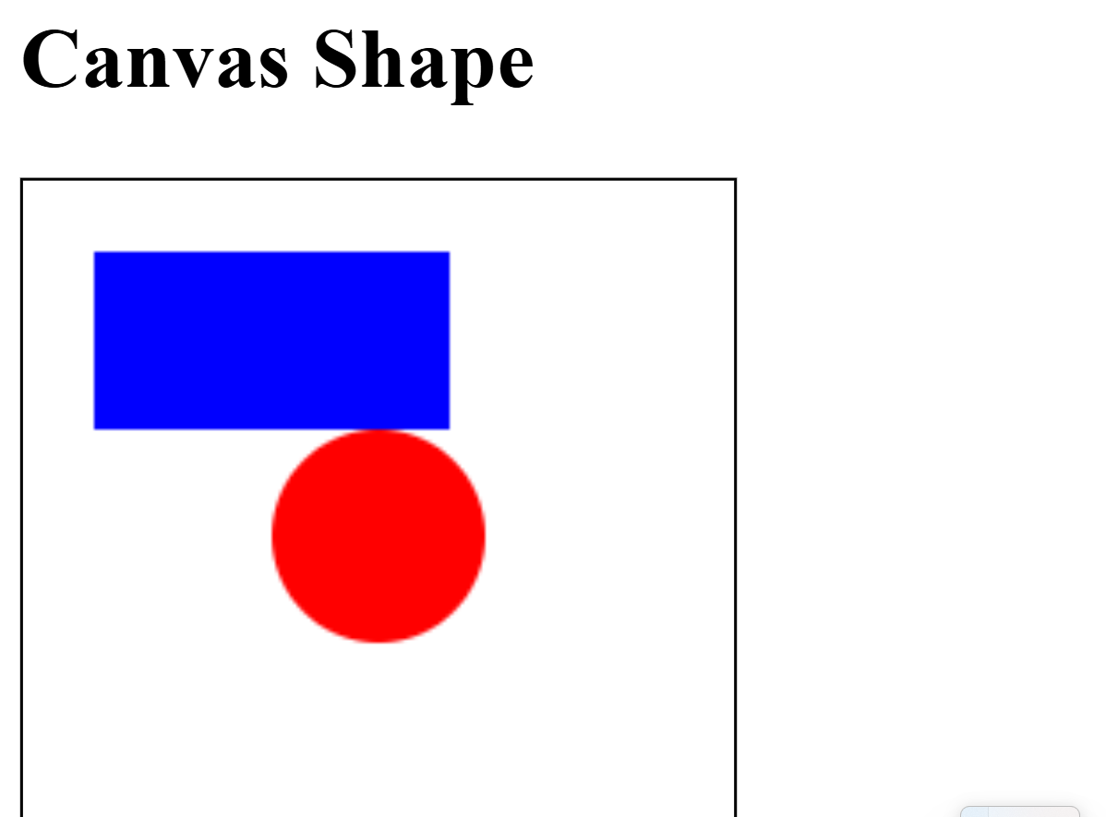

• Create some shape using svg tag in html

Code:

<h2>SVG Shape</h2>

<svg width="200" height="200">

<!-- Rectangle -->

<rect x="10" y="10" width="100" height="50" fill="green" />

<circle cx="100" cy="100" r="30" fill="orange" />

</svg>

Output:

